**PRACTICAL – 1 (1.1)**

**AIM:**

|  |
| --- |
| **Create a program that asks the user to enter their name and their age. Printout a message addressed to them that tells them the year that they will turn 100 years old.** |

**PROGRAM:**

|  |
| --- |
| import datetime  name = input("Enter your Name: ")  age = int(input("Enter your Age: "))  date = datetime.datetime.now()  temp = 100 - age  update = temp + date.year  print(update)  print("\n20DCE019 - Yatharth Chauhan") |

**OUTPUT:**

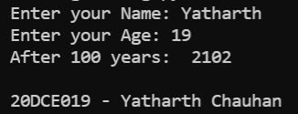

**CONCLUSION:** In this practical we learned about the usage of datetime library, input and print function.

**PRACTICAL – 1 (1.2)**

**AIM:**

|  |
| --- |
| **Write a program to ask the user for a number. Depending on whether the number is even or odd, print out an appropriate message to the user. Hint: how does an even / odd number react differently when divided by 2?** |

**PROGRAM:**

|  |
| --- |
| n = int(input("Enter Number: "))  if(n % 2 == 0):  print("Number is Even")  else:  print("Number is Odd")  print("\n20DCE019 - Yatharth Chauhan") |

**OUTPUT:**

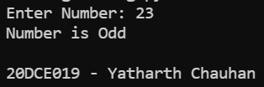

**CONCLUSION:** In this practical we learned about the usage of ‘if’ statement.

**PRACTICAL – 2 (2.1)**

**AIM:**

|  |  |
| --- | --- |
| |  | | --- | | **Write a program as mentioned below:**  **Take a list, a = [1, 1, 2, 3, 5, 8, 13, 21, 34, 55, 89], and write a program that print out all the elements of the list that are less than 5.** | |

**PROGRAM:**

|  |
| --- |
| list = [1, 1, 2, 3, 5, 8, 13, 21, 34, 55, 89]  for i in range(len(list)):  if(list[i] < 5):    print(list[i], end=" ")  print("\n20DCE019 - Yatharth Chauhan") |

**OUTPUT:**

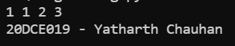

**CONCLUSION:** In this practical we learned about the usage of list and for loop.

**PRACTICAL – 2 (2.2)**

**AIM:**

|  |
| --- |
| **Create a program that asks the user for a number and then prints out a list of all the divisors of that number. (If you don’t know what a divisor is, it is a number that divides evenly into another number. For example, 13 is a divisor of 26 because 26 / 13 has no remainder.)** |

|  |
| --- |
|  |

**PROGRAM:**

|  |
| --- |
| n = int(input("Enter the Number: "))  print("The divisors of the number are:")  for i in range(1, n + 1):  if(n % i == 0):  print(i)  print("\n20DCE019 - Yatharth Chauhan") |

**OUTPUT:**

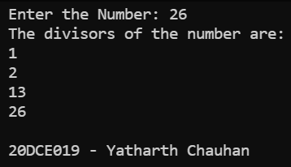

**CONCLUSION:** In this practical we learned about the usage of ‘if’, ’for’ loop and the usage of lists.

**PRACTICAL – 3 (3.1)**

**AIM:**

**Take two lists, a = [1, 1, 2, 3, 5, 8, 13, 21, 34, 55, 89], b = [1, 2, 3, 4, 5, 6, 7, 8, 9, 10, 11, 12, 13] and write a program that returns a list that contains only the elements that are common between the lists (without duplicates). Make sure your program works on two lists of different sizes.**

|  |
| --- |
|  |

**PROGRAM:**

|  |
| --- |
| a = [1, 1, 2, 3, 5, 8, 13, 21, 34, 55, 89]  b = [1, 2, 3, 4, 5, 6, 7, 8, 9, 10, 11, 12, 13]  common = []  a = set(a)  b = set(b)  for i in a:  if i in b:  common.append(i)  print(common)  print("\n20DCE019 - Yatharth Chauhan") |

**OUTPUT:**

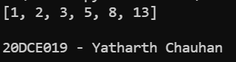

**CONCLUSION:** In this practical we learned about the usage of set.

**PRACTICAL – (3.2)**

**AIM:**

**Write a program by asking the user for a string and print out whether this string is a palindrome or not. (A palindrome is a string that reads the same forwards and backwards.)**

|  |
| --- |
|  |

**PROGRAM:**

|  |
| --- |
| string = input(("Enter a string: "))  if(string == string[::-1]):  print("String is a palindrome")  else:  print("String is not a palindrome")  print("\n20DCE019 - Yatharth Chauhan") |

**OUTPUT:**

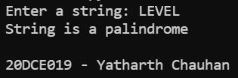

**CONCLUSION:** In this practical we learned about the palindrome.

**PRACTICAL – 4(4.1)**

**AIM:**

**Write one line of Python that takes list a = [1, 4, 9, 16, 25, 36, 49, 64, 81, 100] and makes a new list that has only the even elements of this list in it.**

|  |
| --- |
|  |

**PROGRAM:**

|  |
| --- |
| list = [1, 4, 9, 16, 25, 36, 49, 64, 81, 100]  ans = [i for i in list if i % 2 == 0]  print(ans)  print("\n20DCE019 - Yatharth Chauhan") |

**OUTPUT:**

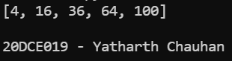

**CONCLUSION:** In this practical I learned the usage of list in python.

**PRACTICAL – 4(4.2)**

**AIM:**

**Write a program to make a two-player Rock-Paper-Scissors game. (Hint: Ask for player plays (using input), compare them, print out a message of congratulations to the winner, and ask if the players want to start a new game) Rules: Rock beats scissors, Scissors beats paper, Paper beats rock**

|  |
| --- |
|  |

**PROGRAM:**

|  |
| --- |
| player1 = input("Enter Player-1 Name: ")  player2 = input("Enter Player-2 Name: ")  p1 = input(  "\n %s, For Player-1: Choose rock, paper or scissors: " % player1)  p2 = input(  "\n %s, For Player-2: choose rock, paper or scissors: s" % player2)  def compare(u1, u2):  if u1 == u2:  return("It's a tie")  elif u1 == 'rock':  if u2 == 'scissors':  return("\nPlayer-1 wins the game")  else:  return("\nPlayer-2 wins the game")  elif u1 == 'scissors':  if u2 == 'paper':  return("\nPlayer-1 win the game")  else:  return("\nPlayer-2 wins the game")  elif u1 == 'paper':  if u2 == 'rock':  return("\nPlayer-1 wins the game")  else:  return("\nPlayer-2 win the game")  else:  return("\nInvalid input")  print(compare(p1, p2))  print("\n20DCE019 - Yatharth Chauhan") |

**OUTPUT:**

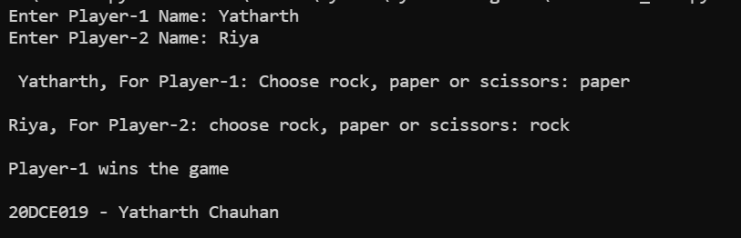

**CONCLUSION:** In this practical we learned the usage of ‘if’’, ‘else’ and ‘elif ‘statement.

**PRACTICAL – 5(5.1)**

**AIM:**

**Write a program to generate a random number between 1 and 9 (including 1 and 9). Ask the user to guess the number, then tell them whether they guessed too low, too high, or exactly right. (Hint: remember to use the user input lessons from the very first practical)**

|  |
| --- |
|  |

**PROGRAM:**

|  |
| --- |
| **from random import randrange**  **a = int(input("Enter user defined number: "))**  **rd = int(input("Random Number: "))**  **if(a > rd):**  **print("It's a high number.")**  **elif(a < rd):**  **print("It's a low number.")**  **else:**  **print("Exactly Same")**  **print("\n20DCE019 - Yatharth Chauhan")** |

**OUTPUT:**

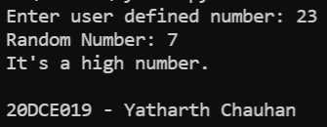

**CONCLUSION:** In this practical I have learned about random library file

**PRACTICAL – 5(5.2)**

**AIM:**

**Write a program to generate a random number between 1 and 9 (including 1 and 9). Ask the user to guess the number, then tell them whether they guessed too low, too high, or exactly right. (Hint: remember to use the user input lessons from the very first practical)**

|  |
| --- |
|  |

**PROGRAM:**

|  |
| --- |
| **a = [1, 1, 2, 3, 5, 8, 13, 21, 34, 55, 89]**  **a = (set(a))**  **b = [1, 2, 3, 4, 5, 6, 7, 8, 9, 10, 11, 12, 13]**  **b = (set(b))**  **ans = a & b**  **print(str(ans))**  **print("\n20DCE019 - Yatharth Chauhan")** |

**OUTPUT:**

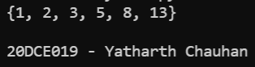

**CONCLUSION:** In this practical I have learned about random library file

**PRACTICAL – 6(6.1)**

**AIM:**

**Write a program using a function to check whether the number is prime or not. (A prime number is a number that has no divisors.)**

**PROGRAM:**

|  |
| --- |
| **num = int(input("Enter the number: "))**  **if num > 1:**  **for i in range(2, int(num/2)+1):**  **if (num % i) == 0:**  **print(num, "is not a prime number")**  **break**  **else:**  **print(num, "is a prime number")**  **else:**  **print(num, "is not a prime number")**  **print("\n20DCE019 - Yatharth Chauhan")** |

**OUTPUT:**

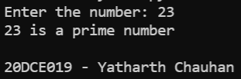

**CONCLUSION:** In this practical we learned about the range operator

**PRACTICAL – 6(6.2)**

**AIM: Write a program that takes a list of numbers (for example, a = [5, 10, 15, 20, 25]) and makes a new list of only the first and last elements of the given list. For practice, write this code inside a function.**

**PROGRAM:**

|  |
| --- |
| **def first_last(a):**  **newlist = []**  **newlist.append(a[0])**  **newlist.append(a[-1])**  **print("First and last Elements of the list are: ", a[-1])**  **return newlist**  **a = []**  **num = int(input("Enter number of elements: "))**  **for i in range(0, num):**  **element = int(input())**  **a.append(element)**  **first_last(a)**  **print("\n20DCE019 - Yatharth Chauhan")** |

**OUTPUT:**

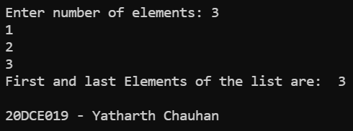

**CONCLUSION:** In this practical we learned about the use of append operator.

**PRACTICAL – 7(7.1)**

**AIM:**

**Write a program that asks the user how many Fibonacci numbers to generate and then generates them. Take 2 1,2 this opportunity to think about how you can use functions. Make sure to ask the user to enter the number of**

**numbers in the sequence to generate. (Hint: The Fibonacci sequence is a sequence of numbers where the next**

**number in the sequence is the sum of the previous two numbers in the sequence. The sequence looks like this: 1,**

**1, 2, 3, 5, 8, 13, ...)**

**PROGRAM:**

|  |
| --- |
| **def FibonacciNum(n):**  **n1 = 0**  **n2 = 1**  **if (n < 1):**  **return**  **print(n1, end=" ")**  **for i in range(1, n):**  **print(n2, end=" ")**  **sum = n1 + n2**  **n1 = n2**  **n2 = sum**  **FibonacciNum(int(input("Enter the range: ")))**  **print("\n\n20DCE019 - Yatharth Chauhan")** |

**OUTPUT:**

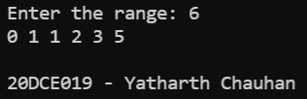

**CONCLUSION:** In this practical we learned about the usage of functions.

**PRACTICAL – 7(7.2)**

**AIM: Write a program (function!) that takes a list and returns a new list that contains all the elements of the first 1,2 list minus all the duplicates.**

**PROGRAM:**

|  |
| --- |
| **def dedupe_v1(x):**  **y = []**  **for i in x:**  **if i not in y:**  **y.append(i)**  **return y**  **a = [2, 3, 3, 2, 5, 6, 7, 8, 5, 6]**  **print("Original list", a)**  **print("Duplicate list", dedupe_v1(a))**  **print("\n20DCE019 - Yatharth Chauhan")** |

**OUTPUT:**

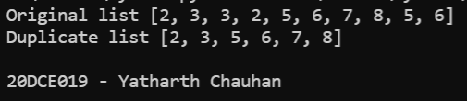

**CONCLUSION:** In this practical we learned about the use of def keyword.

**PRACTICAL -**

**AIM:**

|  |
| --- |
|  |

**PROGRAM:**

|  |
| --- |
|  |

**OUTPUT:**

**CONCLUSION:**

**PRACTICAL -**

**AIM:**

|  |
| --- |
|  |

**PROGRAM:**

|  |
| --- |
|  |

**OUTPUT:**

**CONCLUSION:**